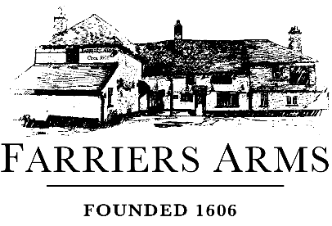

Desserts Menu

Our desserts are lovingly made in house by our chef team. Please discuss any allergies before ordering.
The Farriers double chocolate brownie, honeycomb ice cream, hot chocolate sauce £8.50
The Farriers sticky toffee pudding, vanilla ice cream, toffee sauce £8.50
Apple and blackberry crumble served with hot custard £8.95
Mulled wine, pear and almond tart, candied almonds, Chantilly cream £8.95
The Farriers Cheeseboard with 1606 ale and apple chutney £11.95
Café Gourmand - Supporting Friends of Mersham Church £9.50
An americano coffee or tea (excl. liqueur coffees) & chefs’ choice of mini dessert.
Help us support our local church! We will donate 50p to Friends of Mersham Church Association
to ensure maintenance and upkeep of the building.
Ice-cream or sorbet selection £6 for 3 scoops
Ice cream flavours: Vanilla (ve available), Chocolate, Strawberry, Honeycomb
Sorbet flavours: Raspberry, Lemon, Blood orange
Hot drinks

Single espresso £3.50
Double espresso £4.50
Americano £3.50
Flat white £4.00
Cappuccino £4.50
Latte £4.50
Mocha £5.50
Hot chocolate £4.75
English breakfast tea £3.50
Earl grey tea £3.50
Green tea £3.50
Mint tea £3.50
Chamomile Tea £3.50
Assorted fruit teas £3.50
Liqueur Coffee £8.50
Choice of 50ml shot of Baileys/ Cointreau/ Courvoisier/ Disaronno/ Jamesons/ Tia Maria

