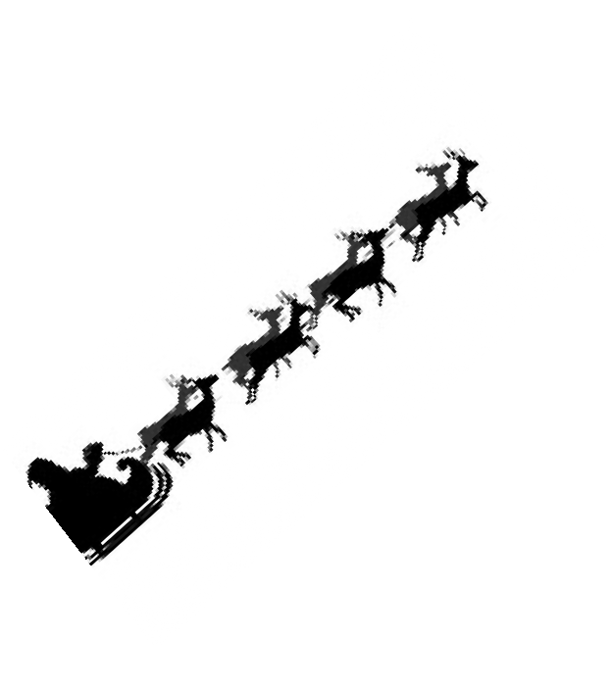
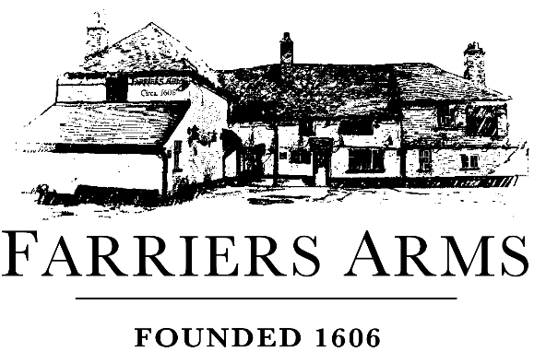

Festive Opening Times 2025

Wednesday 24th December – Christmas Eve
Bar 12-11pm
Restaurant 12-3pm then 5.30-8pm

Thursday 25th December – Christmas Day
Bar 12-3pm
Restaurant – Fully booked

Friday 26th December – Boxing Day
Bar 12-8pm
Restaurant 12-5pm (Classics menu)

Saturday 27th
Bar 12-11pm
Restaurant 12-9pm
Sunday 28th
Bar 12-10.30pm
Restaurant 12-5pm

Monday 29th
Bar 12-11pm
Restaurant 12-3 then 6-8.30pm

Tuesday 30th
Bar 12-11pm
Restaurant 12-9pm

Wednesday 31st December – New Year’s Eve
Bar 12 - 1am
Restaurant 12-3 then 6-9pm

Thursday 1st January – New Year’s Day
Bar 12-10pm
Restaurant 12-5pm (Roast Menu)

