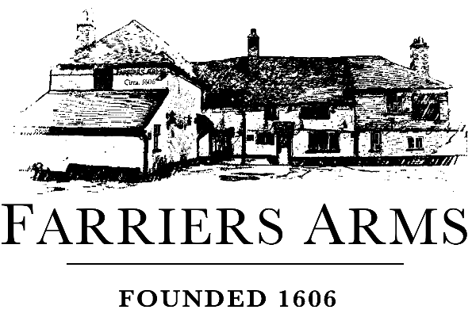
S P E C I A L S
Saturday, 17 January 2026
SOUP
Parsnip and horseradish £8.50

PIE OF THE DAY
Turkey, white wine, and mushroom £19

C A F É G O U R M A N D
A small dessert served with tea or coffee
Miniature brownie £9.50

C H E F S P E C I A L S
Beef wellington for two – Baked garlic mash, charred tenderstem broccoli and peppercorn sauce £52

Confit belly of pork, parmentier potatoes, apple butter, savoy cabbage with bacon, port sauce £22.95

Loin of cod, white wine and orange sauce, crispy crushed new potatoes, baby turnip, radish, capers £23.50

Mushroom Kiev, spiced onion purée, potato fondant, cavolo nero (VE) £18.95

S P E C I A L S
Saturday, 17 January 2026
SOUP
Parsnip and horseradish £8.50

PIE OF THE DAY
Turkey, white wine, and mushroom £19

C A F É G O U R M A N D
A small dessert served with tea or coffee
Miniature brownie £9.50

C H E F S P E C I A L S
Beef wellington for two – Baked garlic mash, charred tenderstem broccoli and peppercorn sauce £52

Confit belly of pork, parmentier potatoes, apple butter, savoy cabbage with bacon, port sauce £22.95

Loin of cod, white wine and orange sauce, crispy crushed new potatoes, baby turnip, radish, capers £23.50

Mushroom Kiev, spiced onion purée, potato fondant, cavolo nero (VE) £18.95

